Name _________________________________ Period ________ Date ____________________
Appeals to Ethos, Pathos, and Logos
Directions: We are going to use the following speech, which was delivered by Lou Gehrig, a professional baseball player who has been recently diagnosed with amyotrophic lateral sclerosis, to complete our evaluation of the use of ethos, pathos, and logos. Lou Gehrig delivered his speech at an Appreciation Day for fans who were chanting “We want Lou!” This chant brought him to the podium to deliver one of the all-time most heartfelt and powerful, yet brief, speeches known today.
Fans, for the past two weeks you have been reading about a bad break I got. Yet today I consider myself the luckiest man on the face of the earth. I have been in ballparks for seventeen years and have never received anything but kindness and encouragement from you fans. Look at these grand men. Which of you wouldn’t consider it the highlight of his career just to associate with them even for one day?
Sure, I’m lucky. Who wouldn’t consider it any honor to have known Jacob Ruppert; also the builder of baseball’s greatest empire, Ed Barrow; to have spent six years with that wonderful little fellow, Miller Huggins; then to have spent the next nine years with that outstanding leader , that smart student of psychology-the best manager in baseball today, Joe McCarthy? Who wouldn’t feel honored to have roomed with such a grand guy as Bill Dickey?
Sure, I’m lucky. When the New York Giants, a team you would give your right arm to beat, and vice versa, sends you a gift-that’s something! When everybody down to the groundskeepers and those boys in white coats remember you with trophies-that’s something!
When you have a wonderful mother-in-law who takes sides with you in squabbles against her own daughter-that’s something! When you have a father and mother who work all their lives so that you can have an education and build your body-it’s a blessing! When you have a wife who has been a tower of strength and shown more courage than you dreamed existed-that’s the finest I know!
So I close in saying that I might have been given a bad break, but I have an awful lot to live for! Thank you.
Lou Gehrig
July 4, 1939
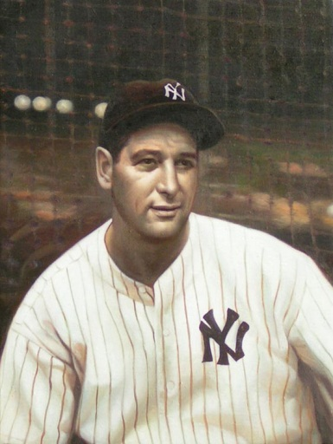

Ethos- An appeal to character, to demonstrate that they are credible and trustworthy.

Logos- An appeal to logic or reasoning. There should be a clear main idea with supporting details.

Pathos- An appeal to emotions. It is common to find figurative language, powerful images, and personal anecdotes.

Ethos
1. How does Lou Gehrig establish ethos in his speech? _________________________________
______________________________________________________________________________
______________________________________________________________________________
2. What common values or feelings does Lou Gehrig share with his fans? __________________
______________________________________________________________________________

Logos
3. What logical point does Lou Gehrig make about his situation? _________________________
______________________________________________________________________________
______________________________________________________________________________
4. What are two points he uses to rationalize his logical point? ___________________________
______________________________________________________________________________
______________________________________________________________________________
______________________________________________________________________________
5. What two contrasting ideas does he talk about that helps him prove his point? ____________
______________________________________________________________________________
______________________________________________________________________________
______________________________________________________________________________
6. What assumption, or underlying belief, links these two seemingly contrasting ideas? _______
______________________________________________________________________________
______________________________________________________________________________

Pathos
1. Which words does Gehrig use that have a positive connotation? ___________, ___________,
___________, ______________, ______________.

2. From what point of view does Gehrig deliver his speech? Why is that significant? __________
______________________________________________________________________________
______________________________________________________________________________
______________________________________________________________________________
3. What image does Gehrig use that is not all that original, yet is a description that the audience understands? Why is the use of this image so effective?
______________________________________________________________________________
______________________________________________________________________________
______________________________________________________________________________

